ESSER FUNDING PLAN OF ACTION
AUGUST 2021

OVERVIEW_________________________________________________________
As we prepare to welcome scholars back to in-person learning after over 18 months of disrupted learning, our Persistence Prep team is united in a commitment to accelerate learning for all scholars and prioritize access to high-quality, grade level content and instructional activities. We believe that only this kind of acceleration approach, paired with mission-driven educators who have the knowledge, skills and habits to execute at the top of their craft will allow us put our scholars on a path towards their ambitious future goals.
To support this commitment to accelerated learning, our team has developed a spending plan that is grounded in six major strategic investment focus areas:
- Creation of an internal teacher talent pipeline
- Full alignment of our literacy program to the Science of Reading research
- Expansion and creation of key staff roles
- Expanded academic opportunities for all scholars
- Staff Development
- Social-Emotional Learning

STRATEGIC INVESTMENT FOCUS AREAS_________________________________
- CREATION OF INTERNAL TEACHER TALENT PIPELINE
A main area of focus will be the creation of an internal teacher talent pipeline to support our continued slow growth as a charter school. With the addition of a new grade level each year through 2025, we will continue to be in need of new teachers who are mission-aligned, highly skilled, and who have a deep understanding of our school culture and instructional expectations. In order to meet this goal, we will develop and maintain a Teaching Assistant pipeline that allows promising candidates to work alongside our classroom teachers and be immersed in our academic program. We will pair this immersion with enrollment in the RELAY Graduate School of Education, through which teachers will earn their Masters degree and obtain their NYS Teaching Certification. An overview of the RELAY Masters program is included as APPENDIX A.
- ALIGNMENT OF LITERACY PROGRAM TO SCIENCE OF READING
In the 2020-2021 school year, we partnered with The New Teacher Project (TNTP) to develop our understanding of the Science of Reading (simple view of reading), and began to make shifts in our literacy program in order to align it to the research. Since that initial partnership, we have developed a comprehensive 3-year plan to fully align our curriculum, RtI services, and assessment program, as well as continue to provide strong training opportunities for staff. The working version of this plan is included as APPENDIX B.
- EXPANSION/CREATION OF KEY STAFF ROLES
In addition to the creation of an internal teacher talent pipeline, we also want to leverage funding to bring on an additional RtI instructor and content coaches earlier than anticipated. Our school is grounded in the belief that effective coaching and immediate feedback is the best way to improve teacher practice, and will leverage additional coaches to shrink coaching caseloads and provide teachers with more individualized support. The expansion of our RtI team will also allow for greater push-in support in classrooms, smaller group sizes for our most struggling scholars, and more targeted instruction tailored to individual demonstrated needs.

- EXPANDED ACADEMIC OPPORTUNITIES
In order to catch our scholars up and accelerate their learning, we need time. We plan to utilize a portion of our funding allocation to ensure our scholars have access to strong morning care, summer learning academy, and a longer school year. This extra time will be leveraged to close scholar gaps in learning, so that core school time can be largely focused on just-in-time supports and grade level instruction.

- STAFF DEVELOPMENT
We firmly believe as a school that a high-quality teacher in every classroom in our building is the number one factor that will drive student achievement. We also believe firmly in the power of collective efficacy amongst our team and embodying the elements of a strong professional learning community. To that end, we want to continue to expand our robust offering of staff development opportunities and allow our teachers to learn from experts in the field, see other high-performing schools in action, and, ultimately, bring their learning back to our community.

- SOCIAL EMOTIONAL DEVELOPMENT
In addition to our focused funding to support our academic programming, we will also utilize funding to purchase and implement a cohesive, developmentally appropriate social-emotional curriculum. The Fly Five curriculum, developed by the Center for Responsive Schools, directly aligns with our Responsive Classroom approach and mindset, and builds upon previous training our staff has received. The curriculum is standards-aligned and spans our entire K-8 grade span. An overview of the curriculum is included as APPENDIX C.
2021-2022 |  | 2022-2023 |  | 2023-2024
ITEM | ~COST | ITEM | ~COST | ITEM | ~COST
Fly Five | $17,310 | Fly Five | $8,535 | Fly Five | $8,535
mClass Assessment | $4,500 | Teaching Assistants (3) | $87,000 | Teaching Assistants (4) | $116,000
mClass Intervention | $3,850 | RELAY tuition | $13,500 | RELAY tuition | $18,000
mClass Intervention Training | $3,200 | Staff Development | $50,000 | Staff Development | $50,000
Summer Learning Academy | $30,000 | Leadership Training | $30,000 | Leadership Training | $30,000
 |  | Summer Learning Academy | $30,000 | Summer Learning Academy | $30,000
 |  | Transportation for Extended school year | $20,000 | Transportation for Extended School Year | $20,000
 |  | CKLA Skills Curriculum K-3 | $20,000 | mClass assessment | $4,500
 |  | mClass assessment | $4,500 | mClass Intervention | $3,850
 |  | mClass Intervention | $3,850 | City Year | $75,000
 |  | City Year | $75,000 | Before School Programming | $30,000
 |  | Before School Programming | $30,000 | RtI Teacher #4 | $45,000
 |  | Literacy Instructional Coach | $60,000
 |  | Math Instructional Coach | $60,000
 |  | RtI Teacher #4 | $45,000
TOTAL: | $58,860 |  | $537,385 |  | $430,885
GRAND TOTAL: | $1,027,130
BUDGET OVERVIEW___________________________________________________________________________

APPENDIX A: RELAY GRADAUTE SCHOOL OF EDUCATION OVERVIEW
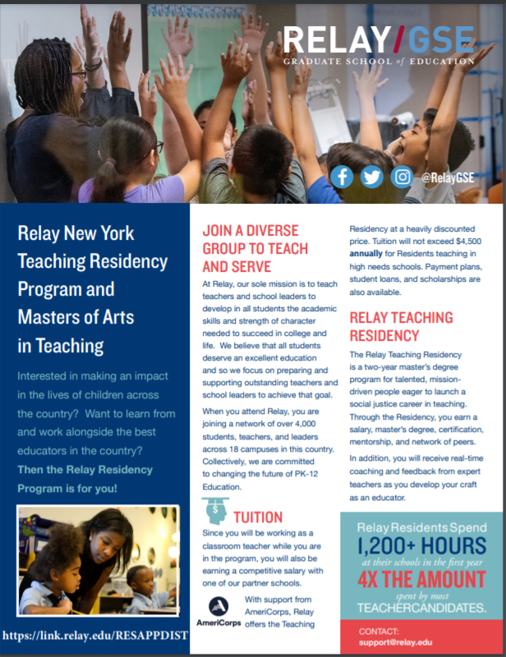
APPENDIX C: FLY FIVE SEL CURRICULUM OVERVIEW
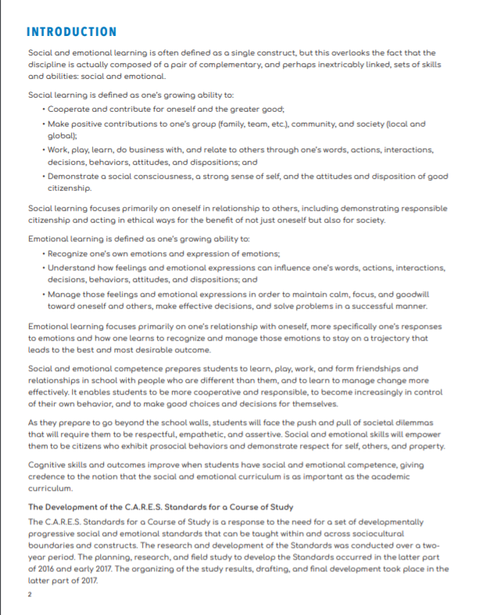
APPENDIX B: SCIENCE OF READING 3-YEAR STRATEGY

